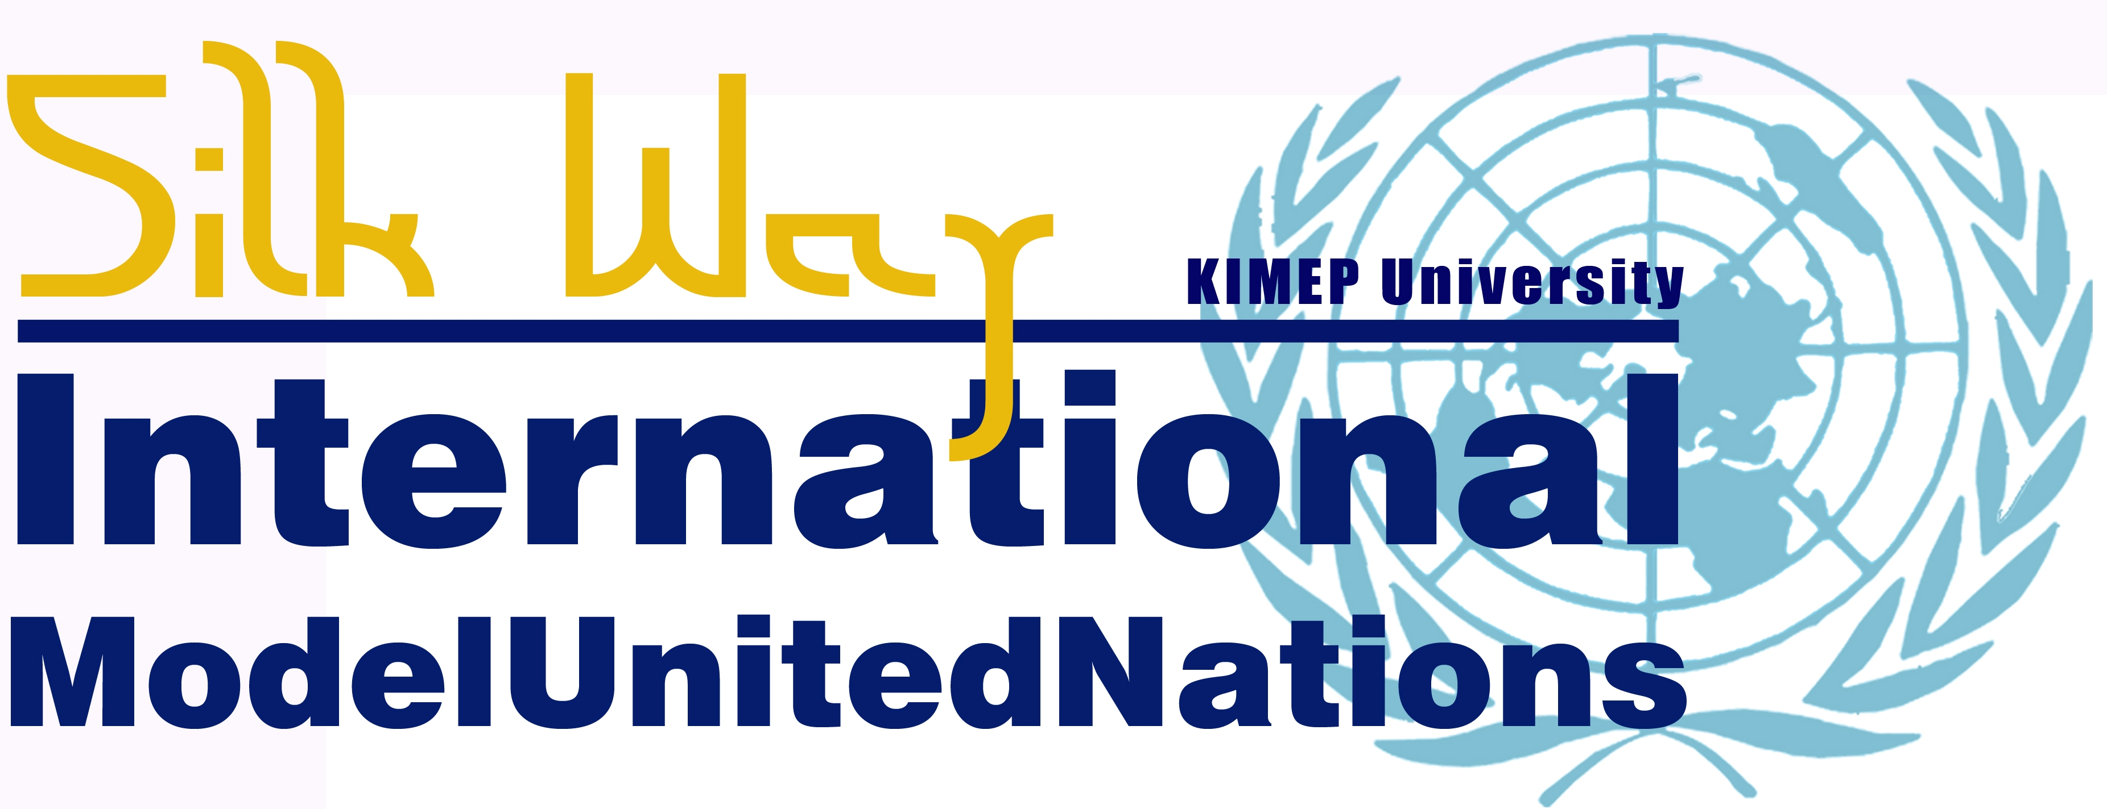
18-20 APRIL 2013

First Committee of the General Assembly on
International Narcotics Trade
The globalization of drug trafficing has increasingly become an alarming phenomenon to be resolved under the United Nations framework since it requires transnational cooperation.
Drug trafficing constitutes as organized crime that violates human rights, directly threatens the security and contributes to the deterioration of societies all around the world. As the problem has become a transnational issue, it is now the role of international organizations, including the United Nations, to find a solution to this problem.
The First Committee of the General Assembly has decided to put the issue on its agenda as the trafficing in drugs often endows the trafficing of firearm and, thus, threatens security. The illicit trade of narcotics includes the exploitation of human mobility to smuggle migrants and the undermining of financial systems through money laundering. ’Every year, countless individuals lose their lives at the hand of criminals involved in organized crime, succumbing to drug-related health problems or injuries inflicted by firearms, or losing their lives as a result of the unscrupulous methods and motives of human traffickers and smugglers of migrants.’
This is why General Assembly, on the recommendation of the General Committee, decided to include in the agenda the item entitled “International drug control” and to allocate it to the First Committee.

On the transnationalization of narcotics trade:

The trading of illegal drugs is a part of the international black market that includes the cultivation, manufacturing, distribution and sale of drugs on a global scale. The use of narcotics, except for medical use, is prohibited in most parts of the world. Trafficing organizations work in different parts of the world and are largely interconnected through the globalized lucrative markets.
According to the World Drug Report 2012 ’at current levels, world heroin consumption (340 tons) and seizures represent an annual flow of 430-450 tons of heroin into the global heroin market. Of that total, opium from Myanmar and the Lao People's Democratic Republic yields some 50 tons, while the rest, some 380 tons of heroin and morphine, is produced exclusively from Afghan opium. While approximately 5 tons are consumed and seized in Afghanistan, the remaining bulk of 375 tons is trafficked worldwide via routes flowing into and through the countries neighbouring Afghanistan.
The Balkan and northern routes are the main heroin trafficking corridors linking Afghanistan to the huge markets of the Russian Federation and Western Europe. The Balkan route traverses the Islamic Republic of Iran (often via Pakistan), Turkey, Greece and Bulgaria across South-East Europe to the Western European market, with an annual market value of some $20 billion. The northern route runs mainly through Tajikistan and Kyrgyzstan (or Uzbekistan or Turkmenistan) to Kazakhstan and the Russian Federation. The size of that market is estimated to total $13 billion per year.’

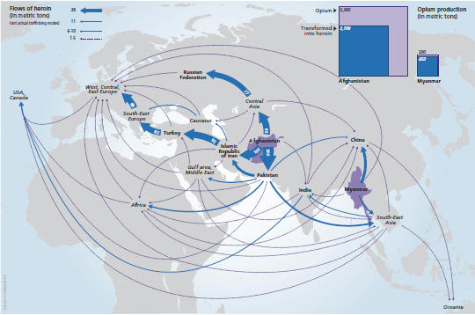

On the connection between narcotics trade and illegal armed groups:

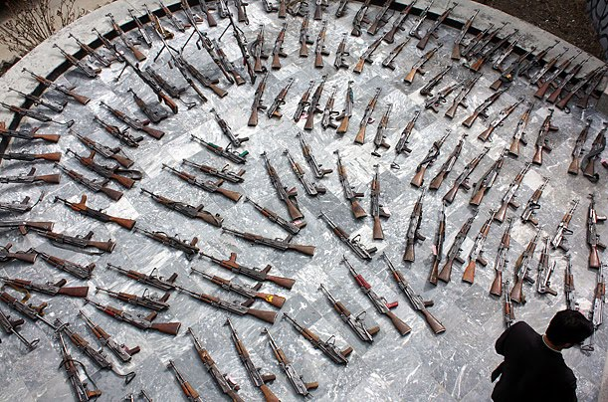
The traffic of illegal narcotic substances often collides with the trafficing of armed weapons. Besides, drug trafficing is often the reason for internal conflicts and low-intensity conflicts in the affected countries. In Colombia, for example, the so-called Revolutionary Armed Forces of Columbia (FARC), which is an anti-government guerilla group, has been associated with drug trafficing as a method of raising funds for continuing to fight for its agenda.
This phenomenon is not restricted to the Americas, organized crime is usually associated with armed groups and terrorist organizations, supplied by the illicit trafic of small arms and light weapons on the global black market. The problem of narcotics especially affects Central Asia, East Asia and Pacific, Mexico, Central America and the Caribbean, Middle East and North Africa and West and Central Africa.

On the United Nations action regarding the illegal trading of drugs:
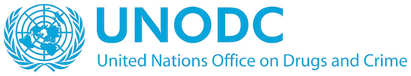
The United Nations has been involved in the transnational cooperation for fighting drug trafficking for decades and as for today multiple UN bodies are involved in the process. There are specific treaties for crime-related, drug-related and terrorism-related issues, all combined under the United Nations Office on Drugs and Crimes (UNODC).
The UNODC was established in 1997 through a merger between the United Nations Drug Control Programme and the Centre for International Crime Prevention and it conducts practical projects with affected member states, as well as research to collect and distribute information about drug and crime related issues. The agency is also responsible for the implementation of the relevant treaties and supporting the development of national legislation on problems of crime and narcotics.
The General Assembly has passed multiple resolutions regarding the topic of the world drug problem, the latest of which is the resolution number A/RES/66/ 183. It calls for the creation of a so-called Integrated and Balanced Strategy to Counter the World Drug Problem. It also calls for other relevant agencies, e.g. WHO, UNODC, UNAIDS, etc. to bolster further action on fighting narcotics trade. The document is based on the report Nr. A/66/ 464 by the Third Committee of the General Assembly on Social, Humanitarian and Cultural Issues. This committee often discusses the humanitarian aspects of drug trafficking.
The security related approach to the problem was discussed in the United Nations Security Council multiple times. The SC stressed the threat drug trafficking means to security, especially concerning illicit cross-border movements and the risks it creates for civilians.

http://www.unodc.org/unodc/en/organized-crime/index.html
http://www.unodc.org/unodc/en/data-and-analysis/WDR-2012.html
http://www.unodc.org/unodc/en/drug-trafficking/index.html
Source: http://www.unodc.org/unodc/en/drug-trafficking/index.html
http://www.bbc.co.uk/news/world-latin-america-11400950
http://www.unodc.org/unodc/en/treaties/index.html?ref=menuside
http://www.unodc.org/unodc/en/about-unodc/index.html?ref=menutop
http://www.securitycouncilreport.org/un-documents/drug-trafficking-and-security/

